User Requirements for Global Forest Change Dashboard with GeoJSON Upload
1. User Roles and Objectives
- Primary Users: Environmental researchers, policymakers, NGOs, forestry departments, and land managers.
- Objectives:
  - Allow users to analyze forest change data for their specific areas of interest (e.g., custom regions, protected areas, or project sites).
  - Enable users to overlay their own spatial data (GeoJSON) with global forest change data.
  - Provide insights tailored to user-uploaded regions.

2. Core Features
- GeoJSON Upload and Integration:
  - Allow users to upload their own GeoJSON files (e.g., polygons representing regions of interest).
  - Validate uploaded GeoJSON files for correct format and projection.
  - Display uploaded GeoJSON layers on the interactive map.
- Interactive Map Visualization:
  - Overlay user-uploaded GeoJSON layers with Global Forest Change data (e.g., forest loss, gain, and net change).
  - Enable users to toggle between different layers (e.g., Global Forest Change data, user-uploaded GeoJSON).
- Custom Analysis:
  - Provide statistics and visualizations for forest change within user-uploaded regions (e.g., total forest loss/gain, annual trends).
  - Allow users to compare forest change data between multiple uploaded regions.
- Data Export:
  - Enable users to download analyzed data (e.g., forest change statistics for their GeoJSON regions) in CSV or GeoJSON format.
  - Allow users to export visualizations (e.g., maps, charts) as images or PDFs.
- User-Friendly Interface:
  - Provide clear instructions for uploading GeoJSON files (e.g., supported formats, size limits).
  - Display error messages for invalid or unsupported files.

3. Data Requirements
- User-Uploaded Data:
  - Accept GeoJSON files containing polygons or multi-polygons.
  - Support common coordinate reference systems (e.g., WGS84).
- Global Forest Change Data:
  - Integrate with the latest version of the Global Forest Change dataset.
- Data Storage:
  - Store user-uploaded GeoJSON files temporarily (e.g., for the duration of the session) unless users opt to save them.

4. Performance and Scalability
- Ensure the platform can handle large GeoJSON files (e.g., up to 100 MB) without performance issues.
- Optimize map rendering for smooth interaction with multiple layers.

5. Security and Privacy
- Ensure user-uploaded GeoJSON files are not accessible to other users.
- Provide an option for users to delete their uploaded files after analysis.

6. Compliance and Standards
- Adhere to open data standards for GeoJSON and spatial data interoperability.
- Ensure compliance with data privacy regulations (e.g., GDPR) if user data is stored.

7. Testing and Feedback
- Test the GeoJSON upload and analysis features with real-world datasets provided by stakeholders.
- Gather feedback on usability and performance.

8. Deliverables
- A fully functional dashboard with GeoJSON upload and analysis capabilities.
- Documentation for users (e.g., how to upload GeoJSON files, supported formats).
- Documentation for developers (e.g., API endpoints for file upload and processing).

9. Timeline
- Provide a project timeline with milestones for:
  - GeoJSON upload functionality.
  - Integration with Global Forest Change data.
  - User testing phase.
  - Final deployment.

10. Success Metrics
- Number of users uploading GeoJSON files.
- User satisfaction with the analysis and visualization features.
- Feedback on the ease of use and performance of the GeoJSON upload feature.

Example User Stories
- As a researcher, I want to upload a GeoJSON file of my study area so that I can analyze forest loss and gain within that region.
- As a policymaker, I want to compare forest change data between multiple regions by uploading their respective GeoJSON files.
- As an NGO representative, I want to download a report with forest change statistics for my project area after uploading a GeoJSON file.

These requirements should help you design a dashboard that meets the needs of users who want to bring their own spatial data to the platform. Let me know if you need further assistance!

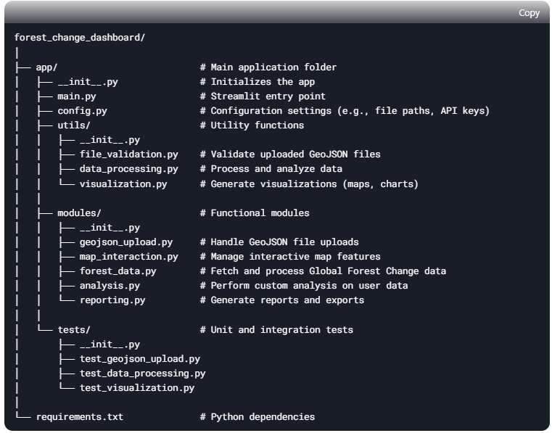

Analysis:
Based on the metadata from the Hansen Global Forest Change v1.11 (2000-2023) dataset, you can derive several new datasets by processing the available bands. Here are some potential analyses and new data products:
1. Forest Change Indices
- Net Forest Change (2000-2023):
Net Change=gain−loss\text{Net Change} = \text{gain} - \text{loss}Net Change=gain−loss
This would highlight areas with a net increase or decrease in forest cover.
- Annual Forest Loss Intensity:
Using the lossyear band, you can generate an annual loss intensity map by aggregating losses over specific time intervals.
- Forest Persistence:
Areas with no recorded loss or gain can be classified as persistent forest cover.
2. Vegetation and Spectral Indices
Using the Landsat-derived bands, you can compute different vegetation indices for both the first (typically 2000) and last (typically 2023) reference years, and analyze changes.
- Normalized Difference Vegetation Index (NDVI)
NDVI=NIR−RedNIR+RedNDVI = \frac{\text{NIR} - \text{Red}}{\text{NIR} + \text{Red}}NDVI=NIR+RedNIR−Red​
Using:
  - first_b40 (NIR) and first_b30 (Red) for the year 2000
  - last_b40 (NIR) and last_b30 (Red) for the year 2023
New Data: NDVI change map, showing vegetation health trends.
- Normalized Burn Ratio (NBR)
NBR=NIR−SWIR2NIR+SWIR2NBR = \frac{\text{NIR} - \text{SWIR2}}{\text{NIR} + \text{SWIR2}}NBR=NIR+SWIR2NIR−SWIR2​
Using:
  - first_b40 (NIR) and first_b70 (SWIR2) for 2000
  - last_b40 (NIR) and last_b70 (SWIR2) for 2023
New Data: Detect burned areas, land degradation, and disturbance trends.
- Normalized Difference Moisture Index (NDMI)
NDMI=NIR−SWIR1NIR+SWIR1NDMI = \frac{\text{NIR} - \text{SWIR1}}{\text{NIR} + \text{SWIR1}}NDMI=NIR+SWIR1NIR−SWIR1​
Using:
  - first_b40 (NIR) and first_b50 (SWIR1) for 2000
  - last_b40 (NIR) and last_b50 (SWIR1) for 2023
New Data: Changes in forest moisture content, useful for drought and fire susceptibility analysis.
3. Temporal Forest Dynamics
- Forest Loss Hotspot Analysis:
By spatially aggregating lossyear, you can generate a heatmap showing regions with frequent forest loss.
- Time Series of Forest Loss:
Extract forest loss trends over time using lossyear at different scales (national, regional, or watershed level).
- Forest Recovery Analysis:
Comparing NDVI or NBR differences between first and last images to detect areas where forest has regenerated after loss.
4. Land-Water Interactions
- Forest Loss in Floodplains & Coastal Zones:
By overlaying the datamask band (identifying permanent water bodies) with loss, you can analyze forest loss near rivers, wetlands, or coastal areas.

However, for the specific analyses listed, the native dataset is entirely sufficient.
TREE_COVER2000 = 'treecover2000' # Percentage of tree cover in the year 2000 (0–100).
LOSS = 'loss' # Binary mask (1 = forest loss, 0 = no loss).
LOSS_YEAR = 'lossyear' # Year of forest loss (1–23, corresponding to 2001–2023).
GAIN = 'gain' # Binary mask for forest gain from 2000–2023.
DATAMASK = 'datamask' # Values: 0 (no data), 1 (land), 2 (water).
FIRST = 'first' # Year of the first loss event.
LAST ='last' # Year of the last loss event.
TREE_COVER_GAIN = 'treecover_gain' # Tree cover increase from 2000 to 2023.
BIOMASS = 'biomass' # Aboveground biomass density in Mg/ha.
DENSITY = 'density' # Canopy density for pixels with >50% cover.

